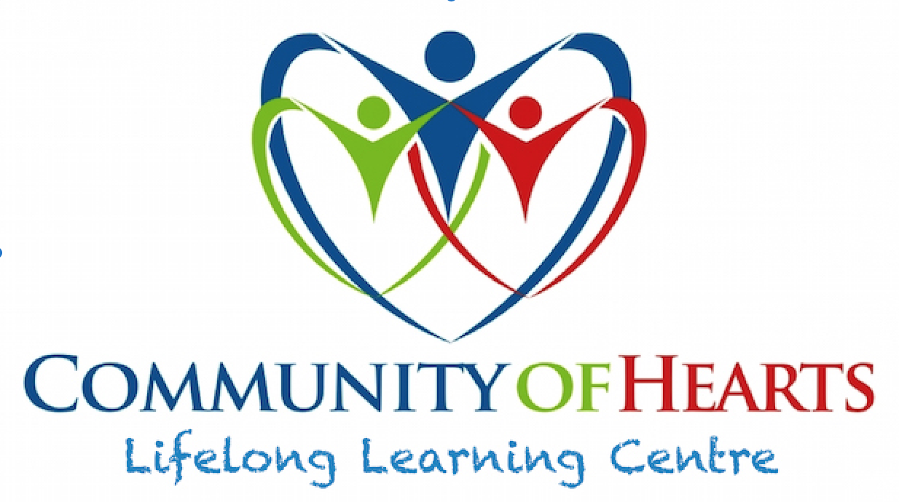
Frequently Asked Questions
Reopening During COVID-19
(September 2021)

What are Community of Hearts’ plans in the areas of physical distancing, health and safety protocols and PPE for when the Lifelong Learning Centre reopens?

- Physical Distancing: Signage on walls and floors will help participants maintain a 2-metre distance from one another, whenever possible. Visual aids and signage will be posted at various locations throughout the Lifelong Learning Centre. Where possible, physical distancing measures will be implemented, including physical distancing of chairs and tables in all rooms, spacing desks apart, creating designated routes to travel through the centre, and the closure of particular rooms including the gym, kitchen and The Creation Station.

- Health and safety: Enhanced cleaning and disinfecting protocols will be in place for the Lifelong Learning Centre and will include protocols and restrictions around cleaning products, touch point cleaning, paper towels, hand cleaning, hand sanitizer, water/tea/coffee/lunch area and multiple times during the day for cleaning more. The Community of Hearts Lifelong Learning Centre has its own cooling/heating/fan systems, independent of the Old Quebec Street Shoppes, providing further assurance for safe ventilation of the air participants and staff will be breathing.

- Personal Protective Equipment (PPE): All participants will be required to wear masks/ or shield inside unless eating or drinking lunch and snacks or if they have a medical exemption card. All participants may wear their own non-medical masks provided that it completely covers their nose and mouth.

- All staff will also be required to be fully vaccinated and will be using Rapid Testing each week before all programs begin. This testing will also be available for participants when needed.

Do I need to be fully vaccinated?
To further protect all the individuals we support as well as staff and volunteers, Community of Hearts is asking all participants returning to in-person programming to show proof of vaccination. Proof of vaccination status can be provided during registration through documentation provided from Public Health. We do not require to see your “vaccine passport” at this time.

What will I be required to do before I can come back to the Lifelong Learning Centre?
Complete and submit the Learning Day Program Participant Form package, proof of vaccination, and register with Community of Hearts for the day/s the participant wants to attend.

How many people will be allowed inside the Lifelong Learning Centre at once? What are the ratios for staff/program participants?
Community of Hearts has decreased the participant spots for each day. Only six participants will be in the program per day, supported by one Life Skills Educator. No more than ten people will be permitted in the Lifelong Learning Centre at any given time.

Who is responsible for screening for COVID-19 symptoms?
Caregivers/participants are responsible for performing at home daily screenings of participants for COVID-19 symptoms before leaving for Community of Hearts using a self-assessment checklist. Staff will be trained in monitoring for the signs and symptoms of COVID-19, and will screen participants upon arrival each day.

What questions will I need to answer each day before entering into the Learning Day Program?
Daily screening questions will include (but may not be limited to):
- Did you or anyone you have had contact with travel outside of Canada in the past 14 days?
- Have you tested positive for COVID-19 or had close contact with a confirmed case of COVID-19?
- Do you have any of the following symptoms? Fever • New onset of cough • Worsening chronic cough • Shortness of breath • Difficulty breathing • Sore throat • Difficulty swallowing • Decrease of loss of sense of taste or smell • Chills • Unexplained fatigue/malaise/muscle aches (myalgias) • Nausea/vomiting, diarrhea, abdominal pain • Pink eye (conjunctivitis)

Will I need to have my temperature checked?
Staff will be trained in monitoring for the signs and symptoms of COVID-19 and will take each participant and staff members’ temperature using a non-invasive infrared thermometer before they enter the Lifelong Learning Centre. Temperatures will be assessed a second time in the afternoon, to ensure no changes have occurred.

What happens if I do not feel well at the beginning of the day, or during the day?
Caregivers and Direct Support Professionals will be notified immediately if the participant becomes unwell. Symptomatic participants will be immediately separated from others and supervised in a designated room until transportation arrangements are made. Caregivers must pick up the participant immediately. If no one is available to pick up the participant immediately, transportation home will be at the participants’ expense.

What will happen if there is a confirmed case of COVID-19 at the Lifelong Learning Centre?
When a participant or staff member has a positive COVID-19 virus diagnosis, the staff and Community of Hearts Board of Directors will follow the directions of Wellington-Dufferin-Guelph Public Health. This may require that we return to a distance-learning model or the Lifelong Learning Centre may be closed to in-person instruction for a length of time as necessary, based on the time recommended by Public Health.

If I get sick and don't have COVID-19, will I be sent home? Will I have to show proof I do not have COVID-19 before I am allowed to come back?
If a participant is sick, it is expected that they remain at home (as per usual). If the participant is sick with symptoms that differ from those associated with COVID-19, they will not be required to provide proof that they do not have COVID-19, but participants will be asked to stay home until their symptoms have resolved for 24 hours. If the participant is sick with symptoms associated with COVID-19, they must be tested for COVID-19 anyways to return and documentation of a clean bill of health is required.

Do I have to wear a mask when I am in the Lifelong Learning Centre?
All participants will be required to wear masks inside unless eating or drinking lunch and snacks.
All participants may wear their own non-medical masks provided that it completely covers their nose and mouth.

Can I wear face shields instead of masks?
In general, we ask that participants wear face coverings/non-medical masks. There may be some cases where participants may be unable to wear a face covering, and staff will address these situations on a case-by-case basis (ie: medical exemption). Community of Hearts will not provide face shields and masks.

Ventilation
Community of Hearts will continue to optimize air quality at the Lifelong Learning Centre through improving ventilation and/or filtration. Ventilation in the Lifelong Learning Centre is not shared with the Old Quebec Street Mall, adding to the protective strategies that will be utilized to support healthy and safe learning environments for participants and staff. Additional measures such as masking, physical distancing and hand hygiene must also be followed.

If I do not wish to return to the Lifelong Learning Centre in person, are there any other options for me?
Community of Hearts is happy to announce that although our Learning Day Program will move to an in-person learning model our Independent Hearts program will be offered virtually. This will give anyone wanting to continue working on life skills the opportunity to have one on one, individualized learning sessions with our Independent Hearts Coordinator. Multiple packages will be available; email independenthearts@communityofhearts.ca for details.

When can a participant who tests positive for COVID-19 return to the Lifelong Learning Centre? Anyone who tests positive will be provided with guidance from Public Health. Those who test positive for COVID-19 must remain in isolation until these three (3) conditions are met: a)They have been isolated for 14 days after the onset of symptoms; AND b) they no longer have a fever; AND c) their symptoms have been improving for at least 72 hours. Participants/staff must be retested for COVID-19 to return and documentation of a clean bill of health is required.

COVID-19 Patient Screening Guidance Document

- Did the person travel outside of Canada in the past 14 days?
- Has the person tested positive for COVID-19 or had close contact with a confirmed case of COVID-19 without wearing appropriate PPE?
- Does the person have any of the following symptoms?

Symptoms | Choose Yes or No
Fever | Yes/No
New onset of cough | Yes/No
Worsening chronic cough | Yes/No
Shortness of breath | Yes/No
Difficulty breathing | Yes/No
Sore throat | Yes/No
Difficulty swallowing | Yes/No
Decrease of loss of sense of taste or smell | Yes/No
Chills | Yes/No
Unexplained fatigue/malaise/muscle aches (myalgias) | Yes/No
Nausea/vomiting, diarrhea, abdominal pain | Yes/No
Pink eye (conjunctivitis) | Yes/No

4. Are they experiencing any of the following symptoms? • Delirium • Unexplained or increased number of falls • Acute functional decline • Worsening of chronic conditions

